Report on
Soft skill development programme:
Date: 21/02/2022 to 25/02/2022
Model: Face to Face mode
Resource person: miss Afreen Ansari and Mrs. Naushin Parkar
Objective :
● Develop effective communication skills (spoken and written).
● Develop effective presentation skills.
● Conduct effective business correspondence and prepare business reports which produce results.
● Become self-confident individuals by mastering interpersonal skills, team management skills, and leadership skills.

Interview Skills(25/04/21)
It is found that students were unable to present themselves in an interview. Theworkshop included interview skills and techniques while giving an interview. Some important tips were given on “Resume Building” and common questions asked during an interview. 58 students attended the event and got benefitted.
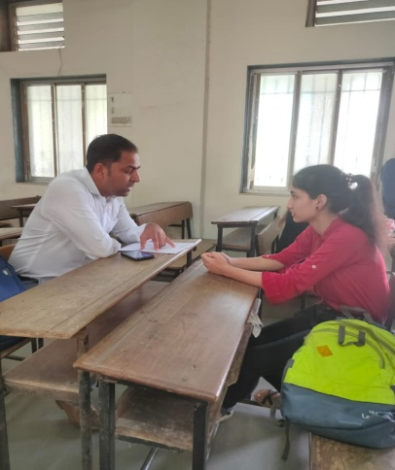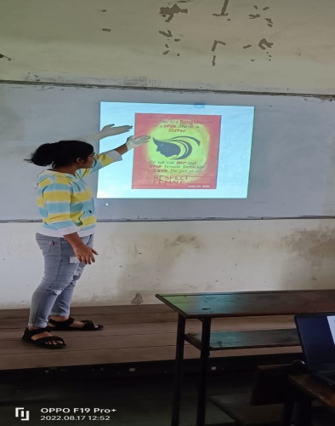
(Interview techniques) (Presentation Skill)
Presentation Skills(28/04/2021 and 29/04/2021)
The main aim was to develop confidence in students and improve their communication skills. This session was taken for students to make them understand the importance of Presentation. They were given important key points to remember while presenting.

